Protecting your Privacy:
☐ I consent to the Parish contacting me to keep me informed about routine Parish business
☐ I consent to the Parish holding and processing my personal details for the purposes of administering the preparation for the sacraments of Reconciliation and First Holy Communion.

I am happy to be contacted by:

☐ email

☐ phone

☐ post

Parents’ signature(s):

……………...………………………...………….

…………………………………………………..

Date: ……………………………………………………

The Parish will use your details to administer the preparation for the sacraments of Reconciliation and First Holy Communion. This may include publishing your name on the weekly newsletter, and/or sharing your information with external organisations when required by Law. You can read the Diocese’s full Privacy Notice on the Parish Website at Register with the Parish | Roman Catholic Parish of Weymouth & Portland (weymouthandportlandrcchurch.org.uk) The parish will securely store your data. Please inform the Confirmation Coordinator or the Parish Office if you no longer want your data to be held and used for Parish routine business. We comply with data protection and marketing legislation and the Fundraising Regulator’s Code of Practice. We do not transfer your data to third parties to use for their own marketing or fundraising purposes.

Always Remember.

What you say in front of children is important.

What we do in front of children is more important.

But what we are and the example we set is most important of all.

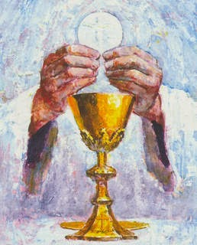

Reconciliation
and
First Holy Communion

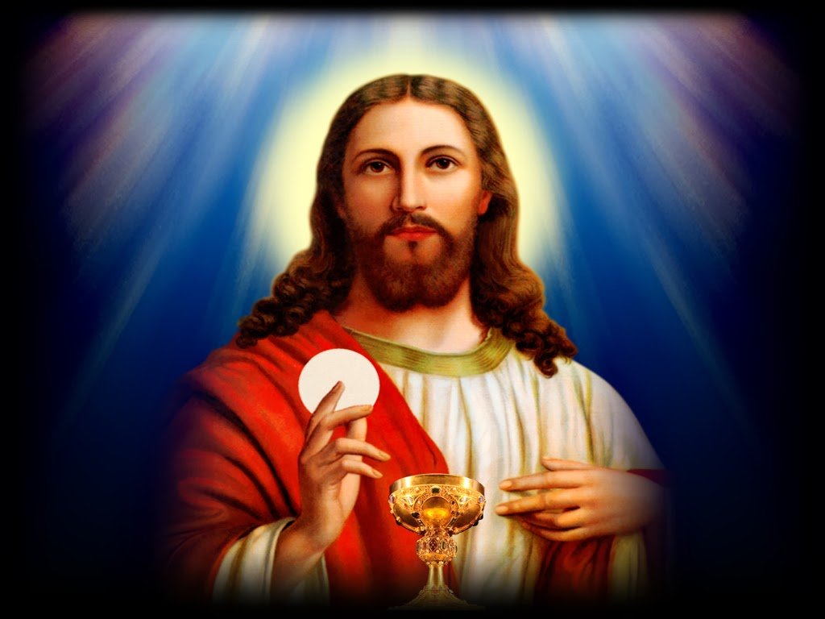

Parish of
Our Lady Star of the Sea
Weymouth



The Sacraments of Reconciliation and First Holy Communion

The preparation for the sacraments of reconciliation and Eucharist is a very special time in the moral and spiritual development of young people.
The programme used here within the Parish promotes active co-operation between parents, catechists, priest, deacons and the entire parish community, whilst recognising the central role of parents as the prime educators in a child’s religious development.
As parents we try to teach our children Christian attitudes and behaviour, and we do this through our daily habits and the living out of our own faith. All of this is part of the Sacramental preparation and for this reason, preparation needs to be a true family journey. Also, working through the course with their child gives parents an opportunity to rediscover their own faith. This is truly a God given opportunity.

What does the course involve?

The young people are prepared for the Sacrament of reconciliation and Eucharist, firstly by their parents who should, in accordance with their baptismal promise, already be bringing their children to Mass each week. All children should be able to recite from memory the Lord’s Prayer (Our Father), Hail Mary, and Glory be…..Once accepted on the course, the children will be expected to come along to weekly sessions usually held at the church after school hours. The programme giving times and dates will be given to all parents whose children are enrolled. The children will also be expected to attend Holy Mass every Saturday evening or Sunday morning throughout the course. There are separate sessions during the course for parents.
Once the children are considered ready by the catechists, and providing they and their parents have been regular attenders at Mass, they will be put forward to the parish priest with the request that they be allowed to make their First Holy Communion. This will take place on the first Saturday after the feast of Corpus Christi. The sacrament of Reconciliation will have been celebrated beforehand.

Thoughts for Parents & Guardians to ponder
This is a special time in the spiritual development of my child. Perhaps now is the time to think through my own values and attitudes:

- Is there any unsolved problem in my own life that I need to put in order?
- By my actions, what am I teaching my child about their faith?
- Do I take my child to mass on a regular basis?
- Do I pray with my child?
- What do I want for my child?
- Do I practically support my child in their growth in faith?
- Do I understand the true meaning of these sacraments and do I use them regularly myself?
If you would like to talk to anyone about these or any other questions you may have, please ask a member of the team, the deacon or priest.

What do I do next?

Simply fill in the attached form email it to the office, or hand it in to the parish priest or one of the catechists after Mass. Alternatively drop the form into the Presbytery. Courses are run annually.

Reconciliation and First Holy Communion Registration Form

I wish to enrol my child in the preparation for the sacraments of Reconciliation and of the Eucharist. I commit myself to support my child on his/her journey, which includes the regular practice of my Catholic Faith. I will make every effort to attend the parents’ meetings.

Child’s Full Name……............................................

Date of Birth............................................................

Father’s Name.........................................................

Mother’s name........................................................

Address...................................................................

..................................................................................

..................................................................................

Post code.....................

T/phone...................................................................

Email …………………………….……………………

Church and date of Baptism:
..................................................................................

..................................................................................

School presently attending....................................

…………………………………………………………...

Please bring your child’s baptismal certificate to the first meeting.

