Baptism is the first of the Sacraments of Initiation into the Body of the Church.

Why Baptism?

Baptism is a sign of God’s love for us. When a new baby is born, we show our love by holding and hugging the child, and perhaps by giving some gift that is a sign of our love. Similarly, through baptism, God embraces a child and gives it the gift of the Holy Spirit. Baptism, Christ tells us, is necessary for salvation.

God’s primary way of working is through His Church. So God’s “embracing” of the child is represented by the child’s reception into the community of the Church, by being “born of the Spirit” the child joins the family of the Spirit which is the Church.

By having your child baptised you are recognising your belief in God and your wish that your child be open to that belief also. You also show that you wish God to be a friend of your child from their earliest days and develop their own personal relationship with God.

Preparation Course

Anyone who is baptised is baptised in the Faith of the Church. As infants cannot profess this faith for themselves, the parents, with the help of Godparents, profess the faith for them.

In order that parents are fully aware of what they are doing and in order to ensure that they are aware of their obligations to God and their child, we provide a short Baptism preparation Course. If you have previously attended a course, we still ask you to come again. This allows you to share your experience, grow deeper in your understanding and help others attending for the first time. These courses explain to parents what they are doing and why. They also explain the Baptism ceremony so that they can understand it better and involve themselves and their family fully in it.

What Do You Have To Do?

Firstly you should be attending Holy Mass regularly with the intention to continue doing so up to and after the Baptism unless there is a good and valid reason for not doing so which you will then have to discuss with the priest. This shows your understanding and acceptance of your own baptismal commitment and the commitment you are about to make on behalf of your child(ren). If you are willing to accept this then, simply fill in the attached form and hand it in to the Parish Office. Baptism dates will be sorted out during the course.

Any enquiries or queries should be made in the first instance to: The Parish Secretary.

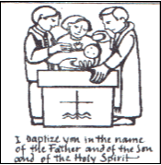

BAPTISM ENQUIRY FORM

Childs full name……………………………….……..

…………………………………………………………..

Date of Birth............................................................

Address...................................................................

..................................................................................

Post code.......................
Phone no ............................

Email:…………………………….…..……………….

Father’s Name.........................................................

Mother’s name........................................................

(nee.........................................................................)

Godparents..............................................................

………………….........................................................

Which Mass do you usually attend?……………...

Protecting your Privacy:

☐ I consent to the Parish contacting me to keep me informed about routine Parish business
☐ I consent to the Parish holding and processing my personal details for the purposes of administering the Baptism Course.

I am happy to be contacted by:

☐ email

☐ phone

☐ post

Signed: ……….……………………..Date: …….……
The Parish will use your details to administer the Baptism. This may include publishing your name on the weekly newsletter, and/or sharing your information with external organisations when required by Law. You can read the Diocese’s full Privacy Notice on the Parish Website at
Register with the Parish | Roman Catholic Parish of Weymouth & Portland (weymouthandportlandrcchurch.org.uk) This parish will securely store your data. Please inform the Baptism Coordinator or the Parish Office if you no longer want your data to be held and used for Parish routine business. We comply with data protection and marketing legislation and the Fundraising Regulator’s Code of Practice. We do not transfer your data to third parties to use for their own marketing or fundraising purposes.

What Baptism preparation involves

The course is discussion based, together with teaching and sharing with the “preparation team” and all parents wishing to have their child(ren) baptised.
Some parents come on the course while they are still expecting the baby. This makes it much easier for both to attend.
This course has proven to be very successful; it has enabled groups of parents to come to know other parents, and to find support within the parish.

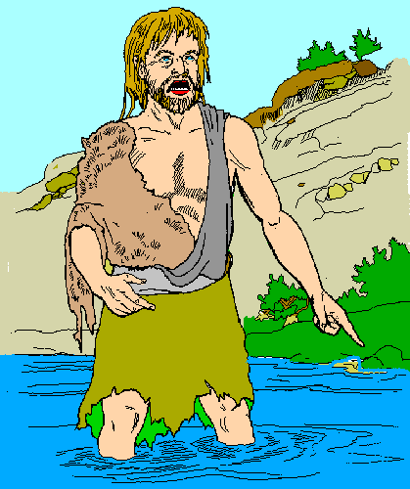

Your Child

If a child lives with criticism,
it learns to condemn.

If a child lives with hostility,
it learns to fight.

If a child lives with shame,
it learns to feel guilty.

If a child lives with tolerance,
it learns to be patient.

If a child lives with encouragement,
it learns confidence.

If a child lives with praise,
it learns to appreciate.

If a child lives with fairness,
it learns justice.

If a child lives with security,
it learns to have faith.

If a child lives with approval,
it learns to like itself.

If a child lives with acceptance and friendship,
it learns to find love in the world.

If a child lives within a family that lives its faith,
it will learn to accept and make that faith its own.

If a child lives within a God-centred family,
it will learn to accept God as its Father.

Preparing
for a
Baptism
in the Parish of

Our Lady
Star of the Sea

A new member of the family is an occasion for celebration. If you are expecting or have had a baby, please accept our congratulations and a promise of prayers from the whole parish community.

We look forward to welcoming your child officially at a celebration of baptism, and at Mass.

This celebration, like the birth itself, requires preparation. In this Parish of Our Lady Star of the Sea we run Baptism Preparation Courses that all parents attend. This leaflet tells you about Baptism Preparation and about arranging the Baptism itself.

