**Sacrament of Confirmation Registration Form.**

I wish to enrol my child in the preparation for the sacrament of Confirmation. I commit myself to the journey which includes the regular practice of my Catholic Faith.

**Candidate’s Full Name................................................**

**………………………………………………………..**

**Father’s Name..............................................................**

**Mother’s name.............................................................**

**(nee...............................................................................)**

**Address................................................................................................................................................................**

**Post code.........................**

**T/phone.......................................................................**

**Date of Birth.................................................................**

**Email:…………………………….………………….**

**Church and date of Baptism:**

**..............................................................................................................................................................................**

**School presently attending..........................................**

**………………………………………………………...**

**Parish presently registered in……………………….**

**……………………………...........................................**

**Thoughts for Parents & Guardians**

**to ponder**

This is a special time in the spiritual development of my child. Perhaps now is the time to think through my own values and attitudes:

• Is there any unsolved problem in my own life that I need to put in order?

• By my actions, what am I teaching my child about their faith?

• Do I take my child to Mass on a regular basis?

• Do I pray with my child?

• What do I want for my child?

• Do I practically support my child in their growth in faith?

• Do I understand the true meaning of these sacraments and do I use them regularly myself?

If you would like to talk to anyone about these or any other questions you may have, please ask a member of the catechetical team or the parish priest or deacon.

**What do I do next?**

Simply fill in the attached form and hand it in to the parish priest or one of the catechists after mass in ordered to be registered for the next course. Alternatively drop the form into the Presbytery. Courses are run annually but take two years to complete. Please bring your child’s Baptismal certificate to the first meeting.

**The Sacrament of Confirmation**

The preparation for any sacrament is a very special time in the moral and spiritual development of young people. The programme used here within the Parish promotes active co-operation between parents, catechists, priests and the entire parish community, whilst recognising the central role of parents as the prime educators in a child’s religious development.

As parents we should be the best educators of our children, particularly in the ways of their faith. We do this through our regular practice and the living out of our own faith. All this is part of the Sacramental preparation and for this reason, preparation needs to be a true family journey. Also, working through the course with their child gives parents an opportunity to rediscover their own faith. This is truly a God given opportunity.

**What does the course involve?**

The young people are prepared for the Sacrament of Confirmation by coming along to sessions held at the church. The programme giving times and dates will be given to all parents whose children enrol for the instruction.

We encourage all our young people, their parents and any brothers or sisters to come regularly to Mass as this helps them grow spiritually and to be part of our community.

The young people, providing they are considered to be ready by the parish priest, will have their names put forward to the Bishop for Confirmation. Dates for the conferring of the sacrament of Confirmation by the Bishop will be given to each family as soon as they are available.

 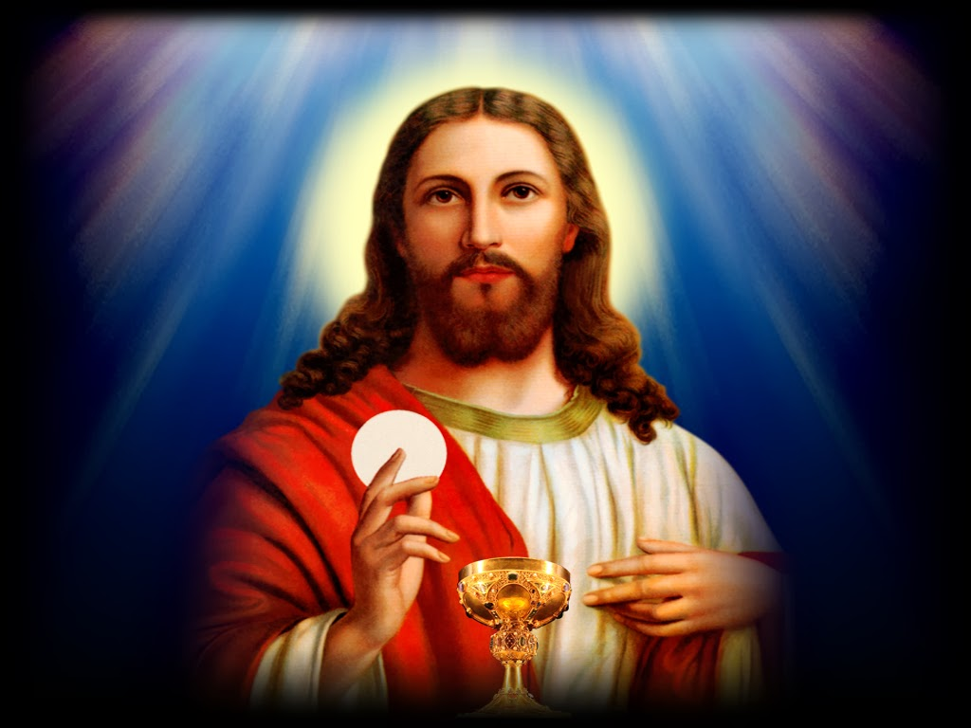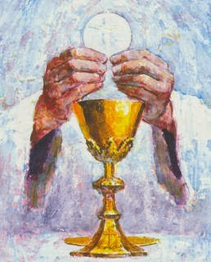

**Protecting your Privacy:**

I consent to the Parish contacting me to keep me informed about routine Parish business

I consent to the Parish holding and processing my personal details for the purposes of administering the preparation for the sacrament of Confirmation.

I am happy to be contacted by:

email

phone

post

Parents’ signature(s) :

……………...……………………….………….

………………………………………….……...

Date: …………………………………………………

The Parish will use your details to administer the preparation for the sacrament of Confirmation. This may include publishing your name on the weekly newsletter, and/or sharing your information with external organisations when required by Law. You can read the Diocese’s full Privacy Notice on the Parish Website at

[Register with the Parish | Roman Catholic Parish of Weymouth & Portland (weymouthandportlandrcchurch.org.uk)](https://www.weymouthandportlandrcchurch.org.uk/register-with-the-parish) The parish will securely store your data. Please inform the Confirmation Coordinator or the Parish Office if you no longer want your data to be held and used for Parish routine business. We comply with data protection and marketing legislation and the Fundraising Regulator’s Code of Practice. We do not transfer your data to third parties to use for their own marketing or fundraising purposes.

**Always Remember.**

**What you say in front of children is important.**

**What we do in front of children is more important.**

**But what we are and the example we set is most important of all.**

***Parish of***

***Our Lady Star of the Sea***

***Weymouth***

***Preparing***

***for***

***the sacraments***

***of***

***Reconciliation***

***and***

***First Holy Communion***



***Parish of***

***Our Lady Star of the Sea***

***Weymouth***

***Preparing***

***for***

***the Sacrament***

***of***

***Confirmation***